“Київський фаховий коледж зв’язку”

Циклова комісія комп’ютерної та програмної інженерії

**ЗВІТ ПО ВИКОНАННЮ**

**ЛАБОРАТОРНОЇ РОБОТИ №3**  
з дисципліни: «Операційні системи»  
Тема: “Знайомство з базовими командами CLI-режиму в Linux”

Виконали студенти

групи БІКС-13

Команда JRSY: Андрущик П.С   
Бурбан Д.Ю.  
Перевірив викладач

Сушанова В.С.

Київ 2023

**Тема:** “Знайомство з базовими командами CLI-режиму в Linux”

**Мета роботи:**

1. Знайомство з базовими командами CLI-режиму в Linux.  
2. Знайомство з базовими текстовими командами в термінальному режимі роботи в різних ОС.

**Завдання попередньої підготовки** (робила студентка Андрущик Поліна)  
1. *Read the short theoretical information for the laboratory work and make a small dictionary of basic English terms on the issues of assigning commands and their parameters.

|  |  |
| --- | --- |
| Термін Англійською | Термін Українською |
| A command the terminal | Команда терміналу |
| Scripting | Сценарії |
| Aliases | Псевдоніми |
| Variables | Змінні |
| Quoting | Цитування |
| Quotes, single quotes, back quotes | Лапки, одинарні лапки, зворотні лапки |
| Control statements | Контрольні твердження |

2. *Define the following concepts:  
**A command interpreter** is a program for controlling a computer through text commands.  
**A shell** is a piece of software that is an "empty" expert system without the knowledge base for any particular application.  
**A command** is an instruction that gives the computer a task.

3. **Answer the following questions:  
**What basic information does the prompt provide?**- user name (who is currently using the computer).  
-hostname (computer name).  
- current directory (where the user is in the file system).  
**Why does the command need parameters and arguments?**  
Parameters and arguments help pass data and instructions to software commands to perform specific operations on that data  
**What is the purpose of ls commands, what options and arguments can it have? Give 3 examples.  
Purpose of commands:** display of a list of files and directories.  
**Parameters:**  
-a: Show all files, including hidden ones.  
-l: Display detailed information about files.  
-h: Display file size in readable format.

**Arguments:** directory or file name.  
Example:  
ls: Display a list of files in the current directory.  
ls -a: Display all files (including hidden ones) in the current directory.  
ls -l /home/user: Display detailed information about files in the /home/user directory.

**How can command history be utilized, and what advantages does it offer?**  
Command history is a list of commands that have been entered in the command line. Benefits include time savings, reduced risk of errors, and aiding in better understanding one's work through previously used commands.

**What is the purpose of the echo command?**  
The echo command is used to display text on the screen.  
example:  
echo "Hello world!"

**Characterize the concept of a variable in the Bash shell, what types of variables does it support?**A variable is a container for storing data.  
Bash uses 2 types of variables:  
**Local:** Only available in the current shell session.  
**Environment variables:** Available to all child processes.

Data types:  
**Text strings:** The most common type.  
**Numbers:** integers and fractions.  
**Arrays:** Collections of data of the same type.

**What is the purpose of env, export and unset commands?  
env:**-Displays a list of environment variables.  
-Can be used to run programs with certain environment variables.  
**export:  
-**Adds a variable to the shell environment.  
-Variables added with export are available to child processes.  
**unset:  
-**Removes a variable from the shell environment

**What commands for getting help on commands in the terminal do you know?  
man** - general command help **help -** short help on the command  
**info -** detailed help on the command **apropos** - search for commands by keywords **whatis** - a brief description of the command  
  
**The main positions of the course of work:**

**Хід роботи. Робив студент Бурбан Данило**

**1. Опрацюйте всі приклади команд, що представлені у лабораторній роботі курсу NDG Linux Essentials -**

**Lab 5: Command Line Skills та Lab 6: Getting Help. Створіть таблицю для опису цих команд**

|  |  |
| --- | --- |
| **Command** | **Purpose and Functionality** |
| **ls** | **Displays information about directories and files. By default, without arguments, it displays information for the current directory.** |
| **ls -1** | **Using the -l parameter with the ls command allows you to display information about files located in the current working directory in a long format, which provides more detailed information.** |
| **ls -1 /tmp** | **Using the /tmp argument in combination with the -l parameter in the ls command allows you to display detailed information about the files in the /tmp directory.** |
| **cd** | **Changes the current directory.** |
| **cd ..** | **Moves up one level in the directory hierarchy.** |
| **cd /tmp** | **Moves to the /tmp directory.** |
| **pwd** | **Displays the current working directory.** |
| **mkdir** | **Creates a new directory.** |
| **mkdir -p /tmp/newdir** | **Creates a new directory /tmp/newdir if it does not exist.** |
| **rmdir** | **Removes an empty directory.** |
| **rmdir /tmp/newdir** | **Removes the /tmp/newdir directory if it is empty.** |
| **touch** | **Creates a new file or updates the access time of an existing file.** |
| **touch file.txt** | **Creates a new file file.txt.** |
| **cat file.txt** | **Displays the contents of the file file.txt.** |
| **more file.txt** | **Displays the contents of the file file.txt one page at a time.** |
| **head file.txt** | **Displays the first 10 lines of the file file.txt.** |
| **tail file.txt** | **Displays the last 10 lines of the file file.txt.** |
| **grep "pattern" file.txt** | **Searches for lines that contain the pattern pattern in the file file.txt.** |
| **sort file.txt** | **Sorts the lines of the file file.txt.** |
| **uniq file.txt** | **Displays unique lines of the file file.txt.** |
| **man ls** | **Displays the man page for the ls command.** |
| **help** | **Displays a list of available commands.** |

**2.1**

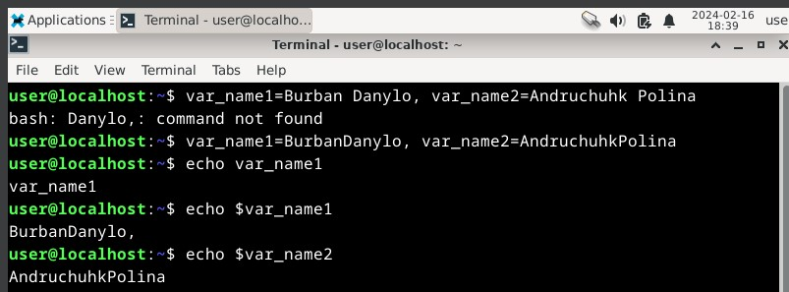

**2.2**

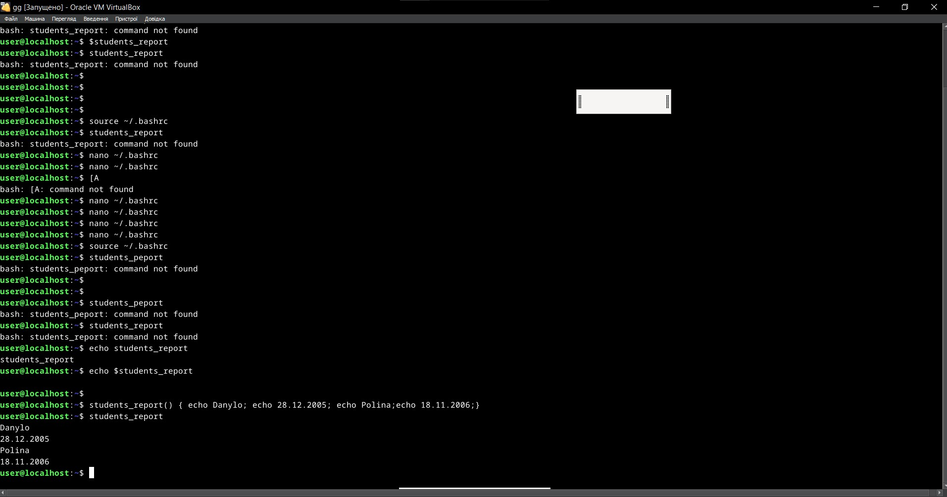

**2.3**

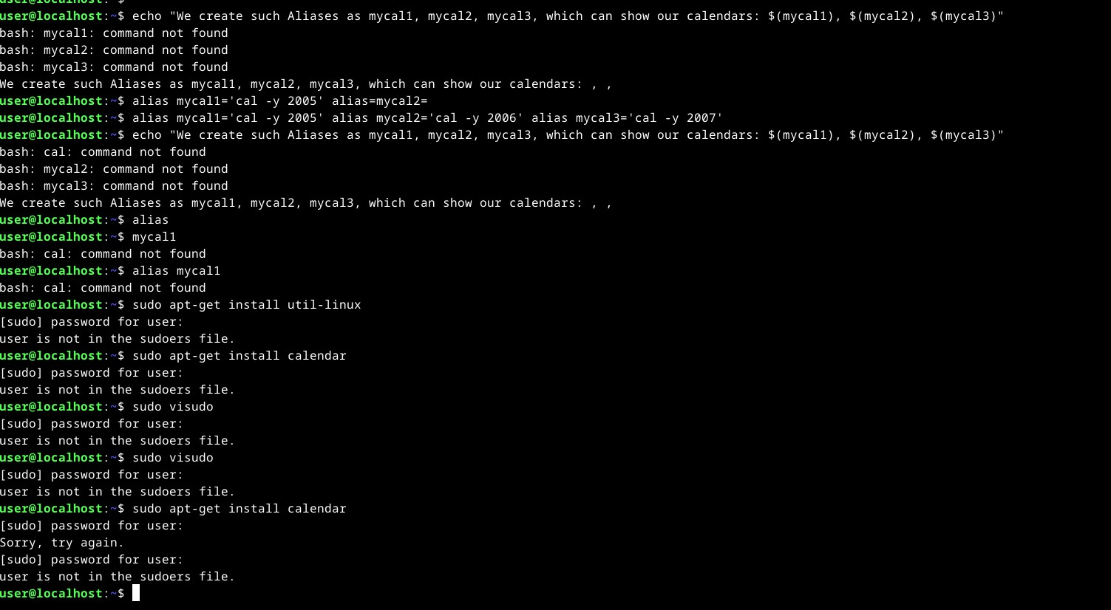

2.4

2.5

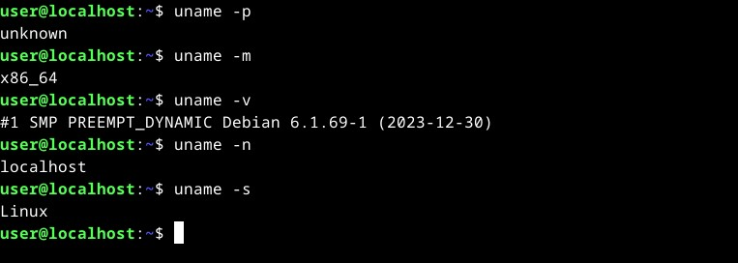

**Відповіді на контрольні запитання: робив студент Бурбан Данило**

**1. What are the command types in the Bash shell?  
Built-in and external**

**2. What are environment variables? What they are. How can they be viewed in the terminal?  
Environment variables are special values that are used by programs and the shell to customize their operation.  
They are system and user  
You can view it as follows:  
env - displays a list of all environment variables.  
echo $VAR - outputs the value of the VAR variable.  
export - displays a list of variables exported to child processes**

**3. *Describe the $PS1 variable. How to view its contents in the terminal?  
$PS1 is an environment variable that defines the text of the command line prompt.  
View its contents in Bash:  
-echo $PS1  
-set | grep PS1**

**4. *How can I change the value of the $PS1 variable? What will happen in the prompt line in bash (the prompt line before starting each command). How to change the value of this variable not to the current session, but to the default?  
You can change the value of the $PS1 variable using the export PS1="new_value" command, which will change the appearance of the prompt on the Bash command line.  
To change the value of an environment variable permanently, it can be modified in configuration files such as .bashrc or .bash_profile for Bash shell, ensuring it applies to future sessions by default.**

**5. *What are quotes used for in the Bash shell?  
Quotation marks in the Bash shell are used to specify strings of text as a single argument, ignoring any special characters within it, except for the $ character, which allows you to refer to variable values.**

**6. **What are control instructions used for, what types do you know?  
Control instructions are used to change the flow of program execution; among their types, conditional, cyclic and unconditional instructions can be distinguished.**

**7. **What is the difference if there is a $ or # at the end of the bash prompt line? For example, we see the following entries on the screen**

**  
The difference between $ and # in the bash prompt.  
The symbol at the end of the bash prompt line indicates the type of user:  
$: regular user.  
#: user with root (superuser) rights.**

**8. **What is the purpose of the whereis and locate commands? What is the difference between them?  
The whereis command is for finding the path to executable files on the system, while locate uses a database to quickly find files by their names; the difference lies in the search method and speed of execution.**

**Conclusion:**

**Worked on a virtual machine. They learned to use aliases and variables, and also learned how to use functions. there were problems. does not want to display the calendar, does not see the “cal”, gives errors, says that it is not possible to install, the problem is with the administrator. they also answered questions, fixed the material.**